class-4-notes.R

farnamtavakoli

2024-01-23

#my first R script  
  
x <- 1:50  
plot(x,sin(x))

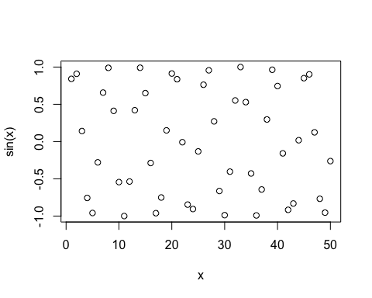

plot(x,sin(x), type="l")

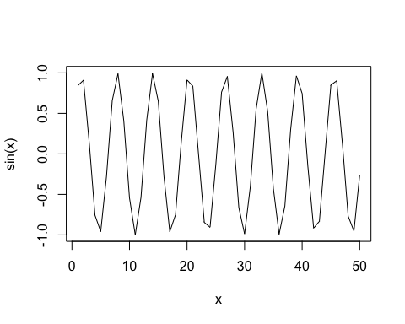

plot(x,sin(x), type="l", col="blue")

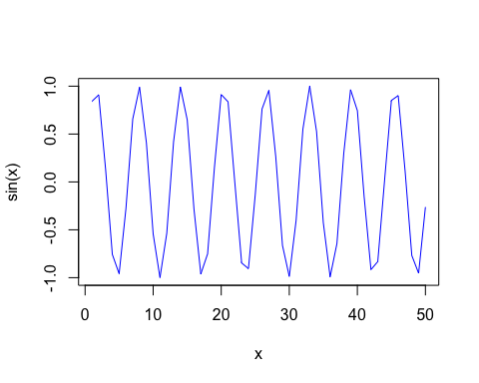

plot(x,sin(x), type="l", col="blue", lwd=2)

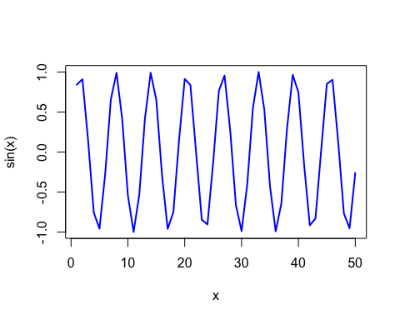

plot(x,sin(x), type="l", col="blue", lwd=2, xlab= "hello")

